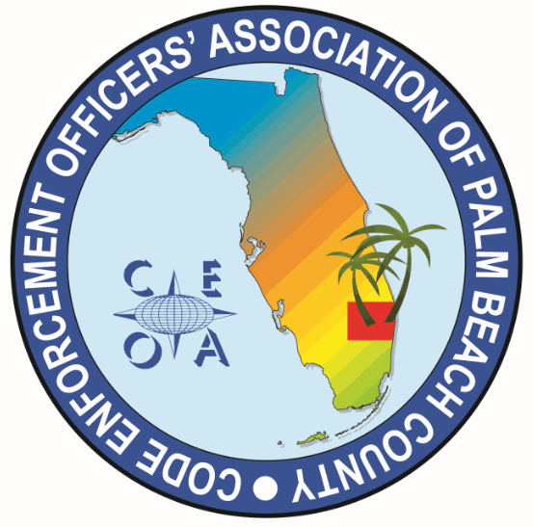
CODE ENFORCEMENT OFFICERS ASSOCIAIION OF PALM BEACH COUNTY
ANNUAL MEETING AGENDA
MARCH 27, 2025
11:30 AM
THE CITY OF WEST PALM BEACH
401 CLEMATIS STREET, WEST PALM BEACH, FL 33401

- CALL ANNUAL MEMBER MEETING TO ORDER AND ROLL CALL OF OFFICERS AND BOARD MEMBERS

- RULES OF MEETING AND ELECTION PROCESS. ESTABLISH A QOURUM OF THE MEMBERSHIP.

- TREASURER REPORT AND PRESENTATION OF THE 2025-2026 BUDGET

- BOARD POSITION RESPONSIBILIITES. NOMINATIONS AND ELECTIONS.

- ELECTION RESULTS. INTRODUCTION OF NEW BOARD MEMBERS

ADJOURNMENT

